Madumal Jeewantha

MDJEE

user guide – Store monitor

Table of Contents

**1.** **Configurations** 2

1.1. Welcome to Configuration Wizard 2

1.2. Store Monitor Database Configurations 2

1.3. Successful message 4

**2.** **User Registration** 5

2.1. User Registration 5

2.2. Security Questions 6

**3.** **Home** 9

**4.** **Store** 11

4.1. Add to Store 12

4.2. Product Details 15

4.3. Store Details 18

4.4. Vehicle Details 19

4.5. Send to Vehicle 20

4.6. Balance Stock 26

**5.** **Settings** 29

5.1. About 30

5.2. User Accounts 31

5.3. Security Center 32

5.4. Vehicles 34

5.5. Reports 35

# **Configurations**

## Welcome to Configuration Wizard

After installation of Store Monitor you will see “Configuration Wizard” as shown below in your first run. Click “Next” to proceed configuration wizard. Here application will build everything which need to be run smoothly. So this wizard will appear only in your first run.

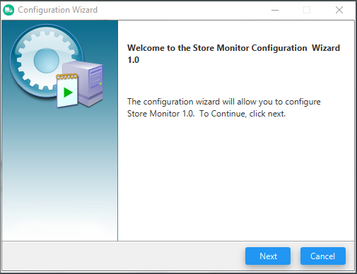

Figure - Welcome to configuration - Configuration Wizard

## Store Monitor Database Configurations

Then you will be directed in to Store Monitor database configurations. Please add MySql server configurations here as shown in below image.

Once you have filled all the fields click “Execute” to start configuring the environment for you. If you already having a database from your one of previous installation, you will be notifying to confirm override existing database (Caution: Existing data will be lost). Please do accordingly.

Note: By default, some fields are filled with most common values to improve user experience. Feel free to use relevant values whatever you having.

Highly recommend to use strong password to prevent from unauthorized access.

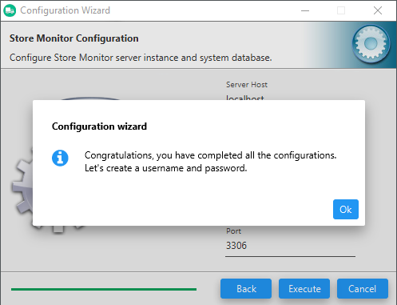

Figure - Database Configuration- Configuration Wizard

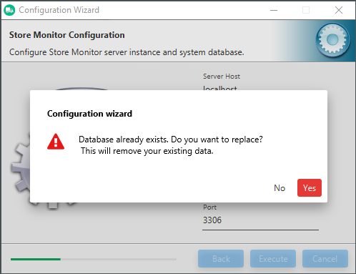

Figure - Database Already Exists Warning- Configuration Wizard

## Successful message

If everything went well you will see below successful message. Then next step will be user account creation, for that click “Ok” in the message box.



Figure - Successful Message - Configuration Wizard

# **User Registration**

## User Registration

After successfully completing configuration process you will be prompt user registration window. Since this is a part of configuring your environment this will appear only at your first run.

As shown in below image you have to create a username and strong password.

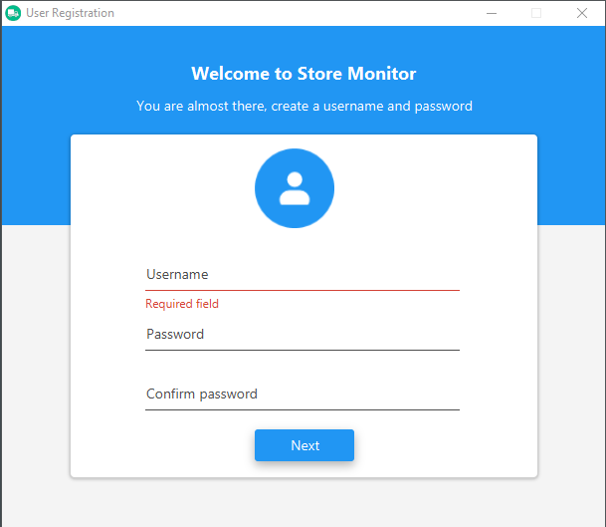

Figure - Create a User - User Registration

## Security Questions

After creating a username and password next step would be adding three security questions for your account. If you forgot your password in future, you will be able to recover password using their security questions.

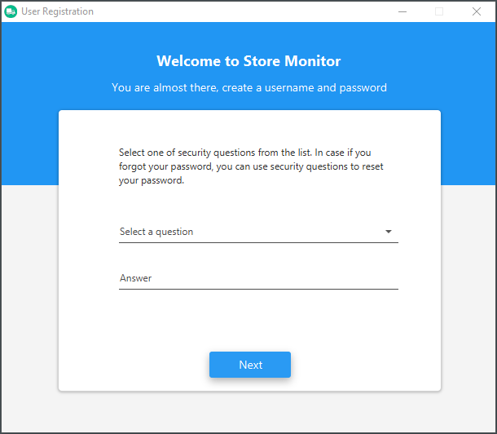

Figure - Add a Security Question - User Registration

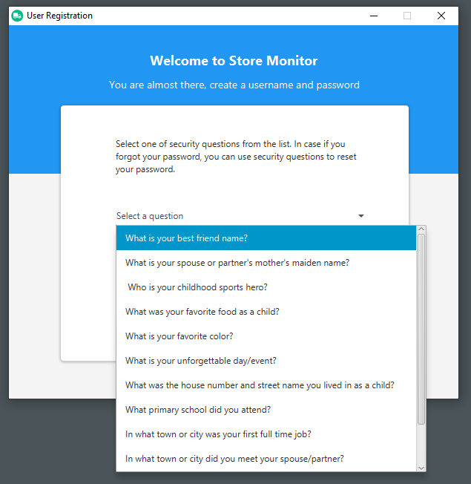

Figure - List of Security Questions - User Registration

Store Monitor is ready to use after creating three security questions. If you have completed everything you will see window similar to below image.

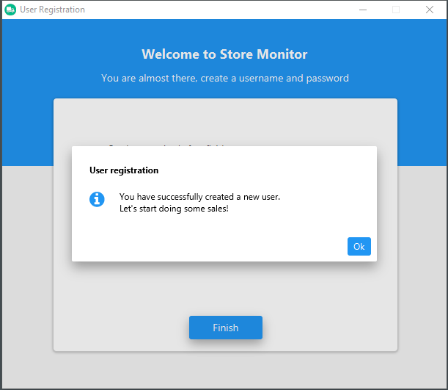

Figure - Successful Message - User Registration

# **Home**

After successful login to Store Monitor it will directed to “Home” window. Here you have tile interface to access main components of Store Monitor.

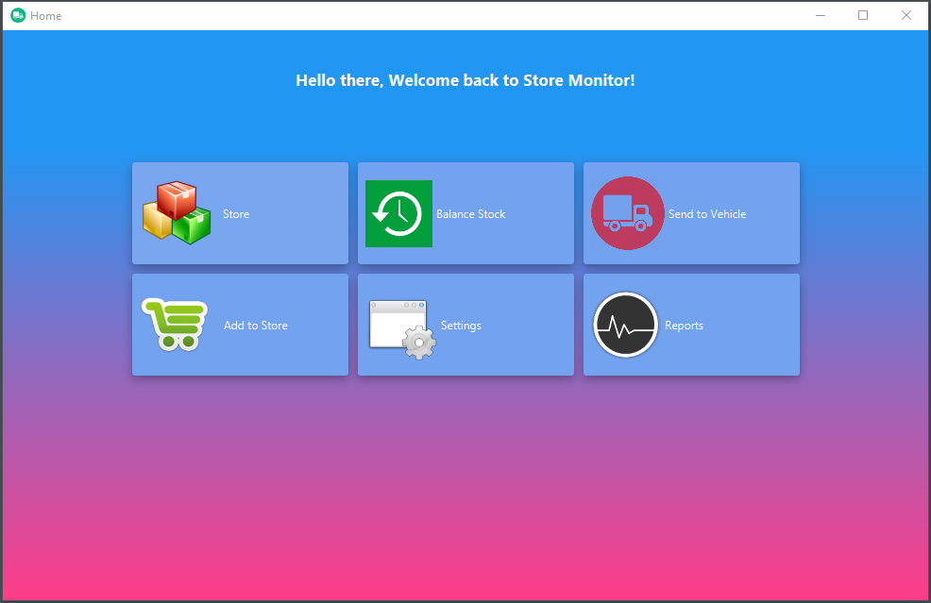

Figure - Tile Interface – Home

If you are closing “Home” window you will get bellow warning message because if you close “Home” window entire application will be close and there can be some unsaved change you may forgotten.

So please consider before closing “Home” window regarding you unsaved works.

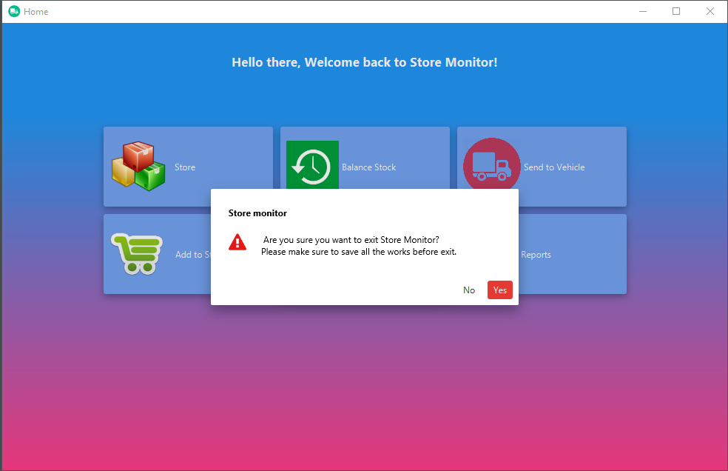

Figure - Exit Warning – Home

As shown in below image you can see tile highlighting to improve user experience.

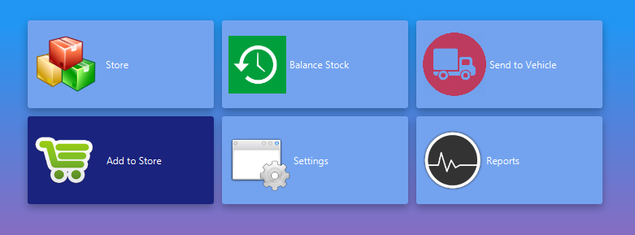

Figure - Add to Store Tile - Home

# **Store**

In “Home” window you have several tiles to access “Store” related functions. Ex: If you click directly “Store”, It will show “Store” window. And if you click “Add to Store” it will open “Store” window with “Add to Store” user interface.

In “Store” window you have menu bar and side pane both options to navigate different options inside “Store” window. Feel free to use your any option.

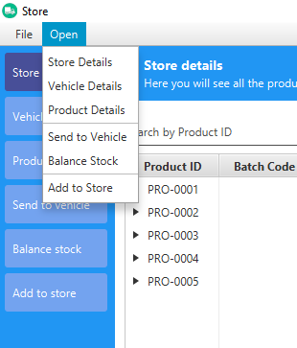

Figure - Menu Bar – Store

## Add to Store

As a first step you have to add your products to “Store Monitor”.

Note: In order to do this, you should have at least one vehicle added to Store Monitor. If you don’t have while going to “Add to Store” application will redirect to “Vehicle” section in “Settings” window.

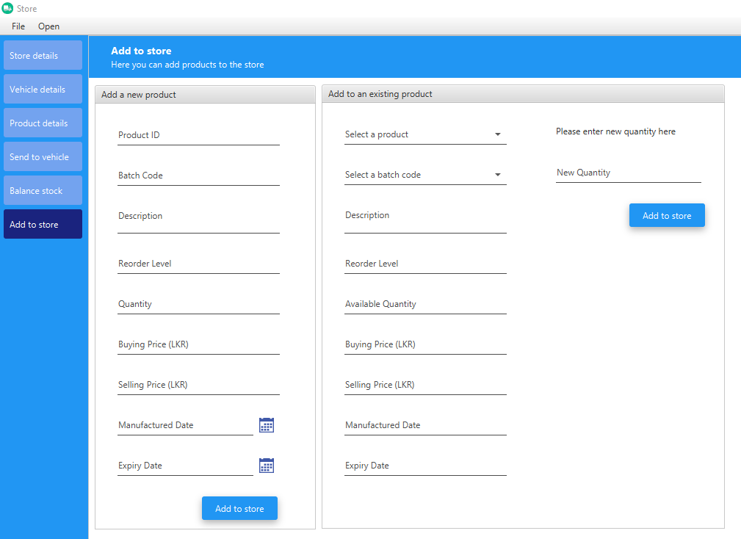

Figure - Add to Store - Store

According to above image you will notice there are two main sections of “Add to Store” section. If you are going to introduce a new product to “Store” you have to use “Add a new product” pane. After that in future you are adding new quantity to existing product you have to use “Add to an existing product”.

When you are adding new product to “Store” there are some required fields to be filled. (Marked in red below image)

If you have already added, you can choose a product from drop down

* **Product ID**: Your product unique identifier (unique name)
* **Batch Code**: This can be used as a sub category of product.
* **Description**: Product description
* **Re-order Level**: Number of quantity you would like to keep all the time in your store
* **Quantity**: Number of quantity you are going to add to Store
* **Buying Price**: Price you have purchased a single item
* **Selling Price**: Price you would like to see to customer
* **Manufactured Date**: Product manufactured date
* **Expiry Date**: Product expiry date

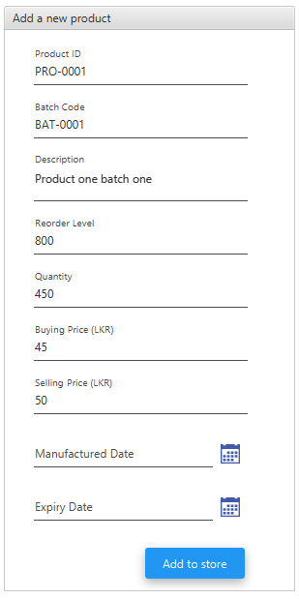

Figure - Add a new Product – Store

You will see below successful message accordingly if product stored successfully.

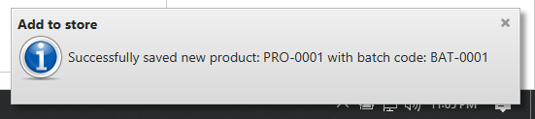

Figure - Successful Message - Add a new Product – Store

If you are adding to an existing product you have to use “Add to an existing product” pane as shown in below image (Required fields are marked in red).

You can choose a product from drop down. Then other fields populate accordingly for your reference

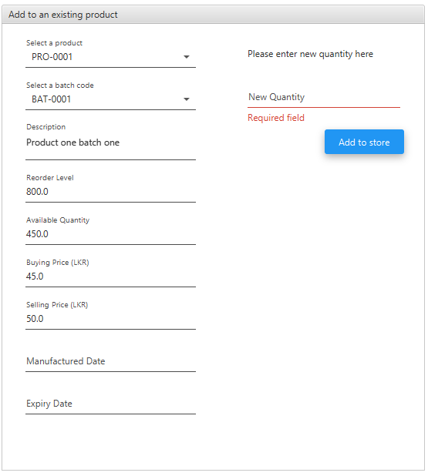

Figure - Add to an Existing Product - Store

## Product Details

Here is the place you can see all the products you have (except vehicle products quantity) in “store”. As shown in below image there features to search, update and delete “Store” products.

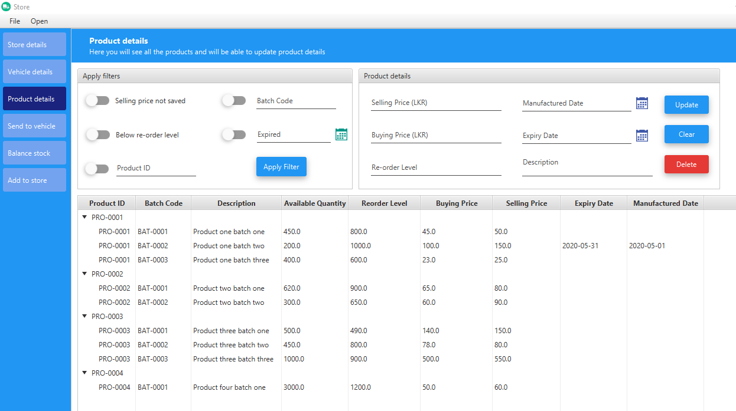

Figure - Product Details - Store

If you want to delete a product including entire batches you have to click on root node of the product and then click delete button or click delete from right click menu. And if you want to delete a single batch from a product you have to select relevant batch and do the same.

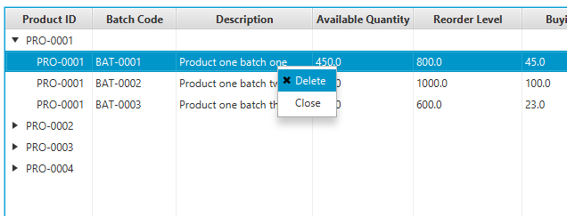

Figure - Right Click Menu - Product Details - Store

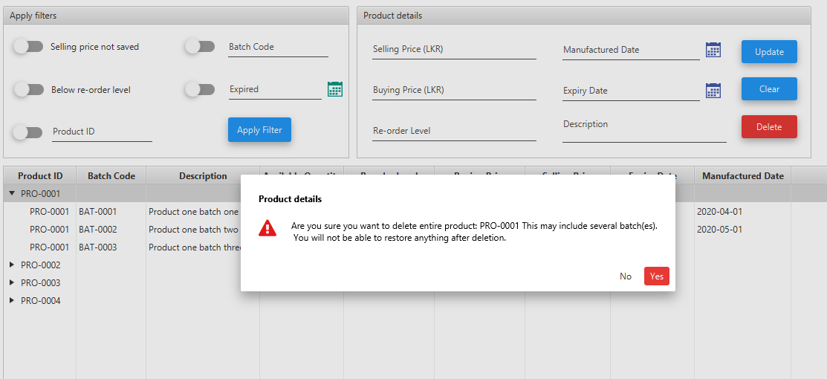

Figure - Warning Message - Deleting Entire Product Including Several Batches - Product Details – Store

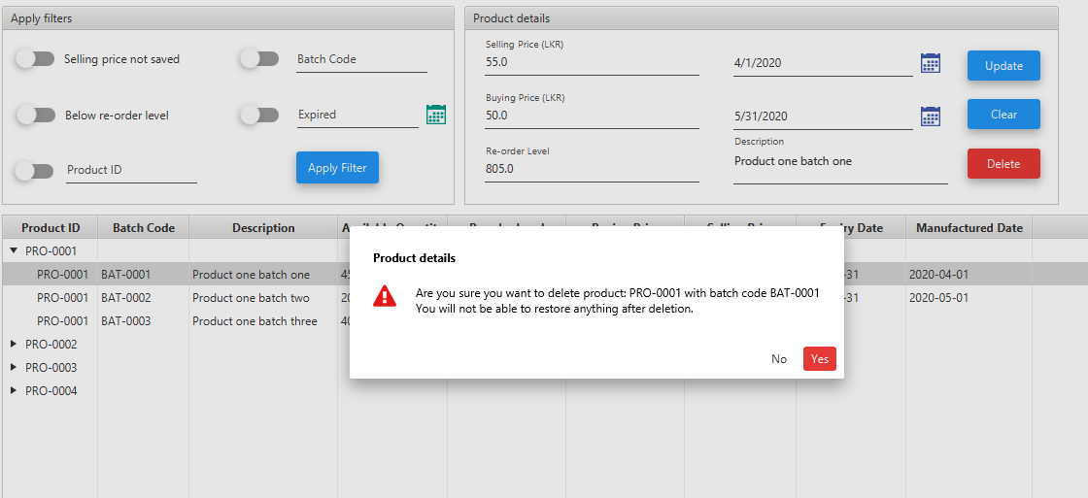

Figure - Warning Message - Deleting Selected Batch From a Product - Product Details - Store

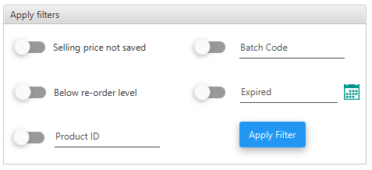

Figure - Available Filters - Product Details – Store

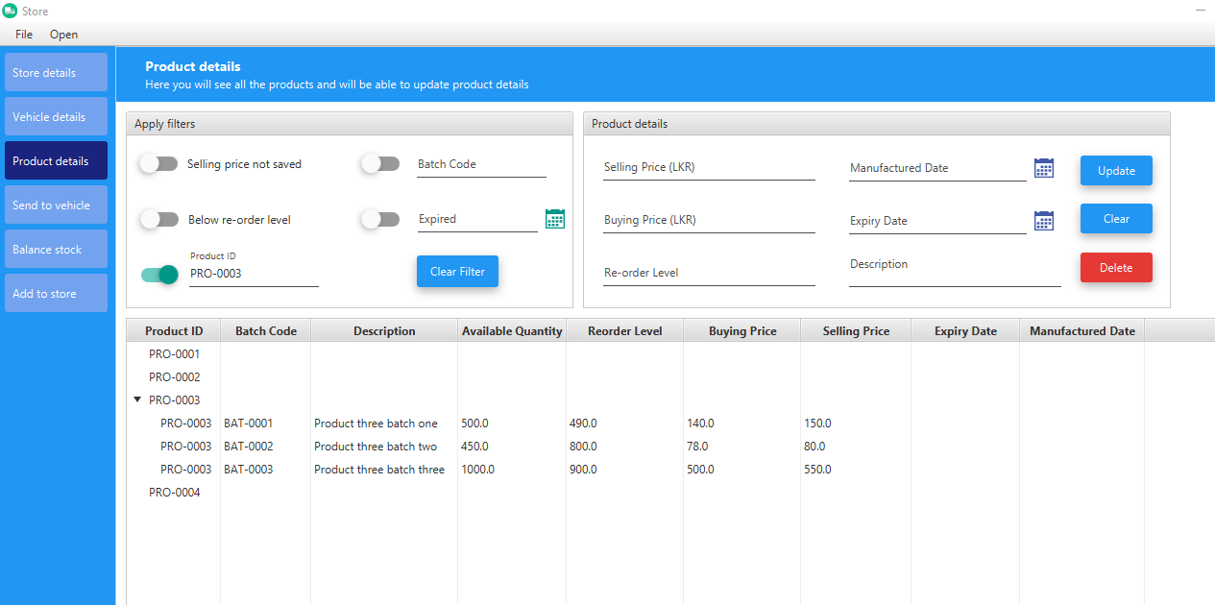

Figure - Product Update Feature - Product Details – Store

## Store Details

Here you will see only product details which are stored in store (excluding vehicle products). This is like a limited features edition of “Product Details”.

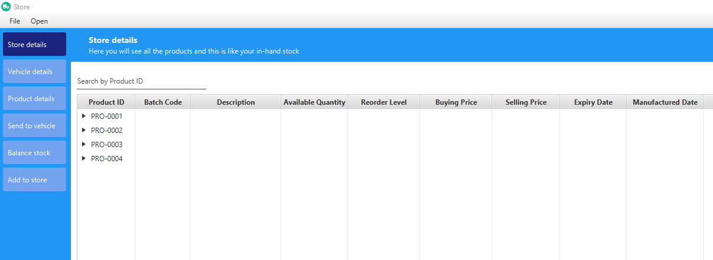

Figure - Store Details – Store

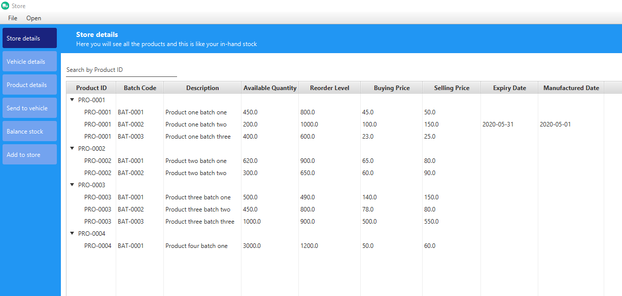

Figure - Store Details - Expanded View – Store

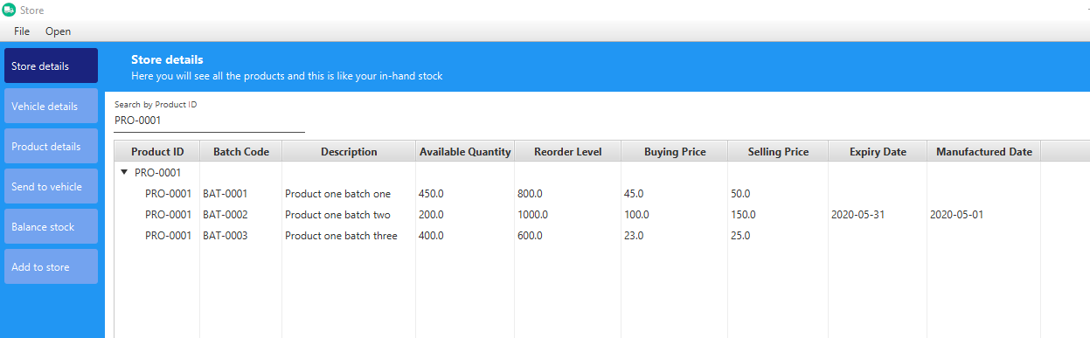

Figure - Search Feature - Product Details – Store

## Vehicle Details

Here you will see product details which are loaded to vehicles.

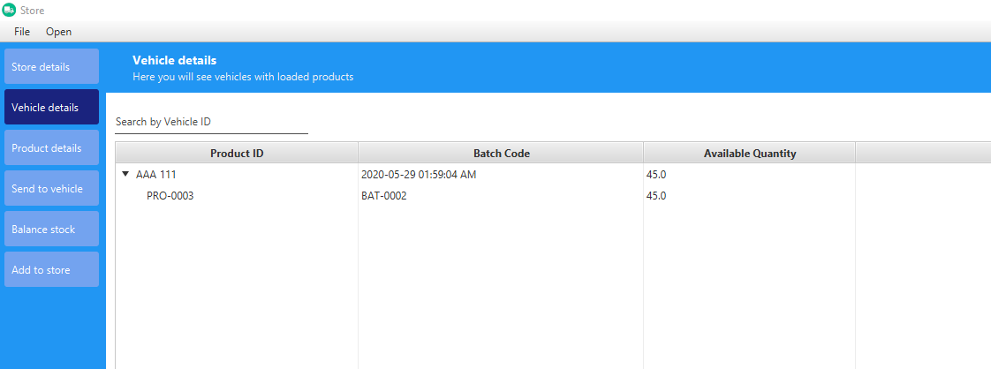

Figure - Vehicle Details –Store

## Send to Vehicle

After adding products to “Store”, you can start loading vehicles. As shown in below image first you have to select a vehicle.

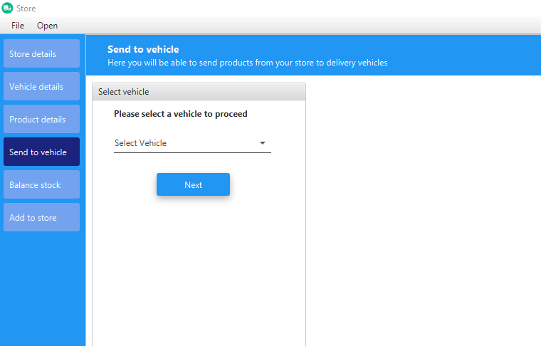

Figure - Send to Vehicle –Store

If you have already loaded (not balanced yet) vehicle with some products, you will see loaded products otherwise you can start freshly.

Below you can see user interface you will get after selecting a vehicle. From here you can start loading products to selected vehicle. When you have loaded relevant products click “Finish Loading” button (you may ask for confirmation to finish).

Note: There are options to add and delete products including going back feature.

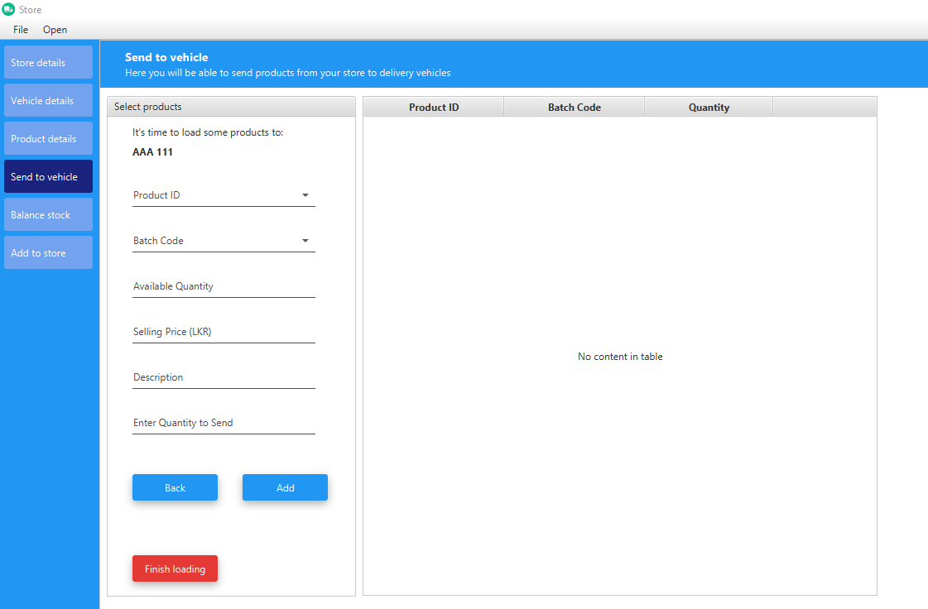

Figure - Add Products - Send to Vehicle – Store

You can choose a product from drop down. Then other fields populate accordingly for your reference

After adding all the products, click “Finish Loading” to complete loading process for selected vehicle

Go back to select another vehicle (Ask for the confirmation to prevent from unsaved changes)

Add selected product to selected vehicle

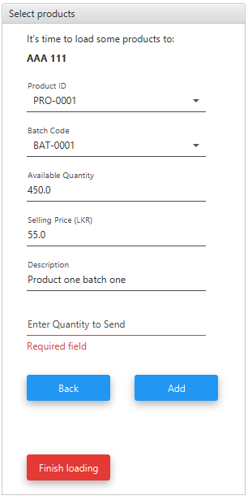

Figure - Select Product Pane - Send to Vehicle - Store

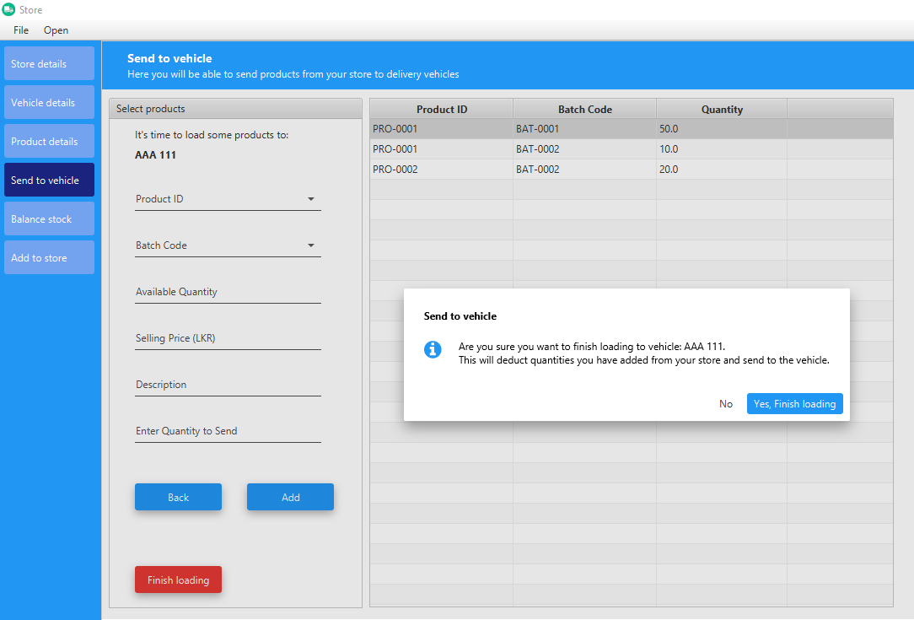

Figure - Finish Loading Confirmation Message - Send to Vehicle –Store

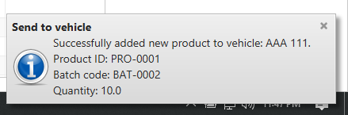

Figure - Successfully Added New Product Notification - Send to Vehicle -Store

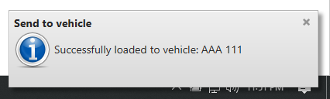

Figure - Successfully Loaded Notification - Send to Vehicle – Store

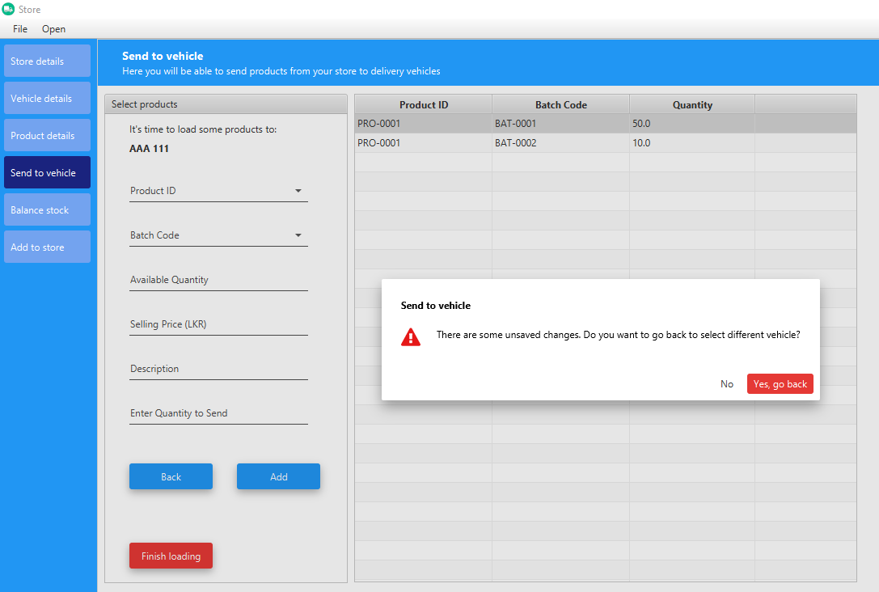

Figure - Going Back to Select Another Vehicle - Send to Vehicle – Store

If you don’t have updated selling price you won’t be able to add to vehicle, before sending you have to update “Selling Price” from “Product Details” section.

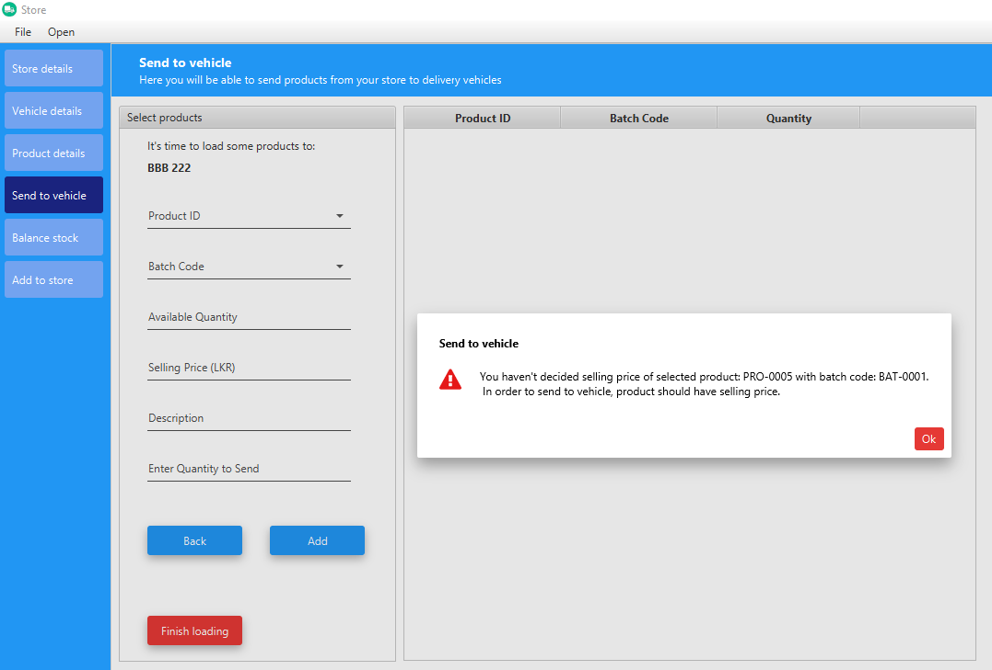

Figure - Product Selling Price Warning - Send To Vehicle –Store

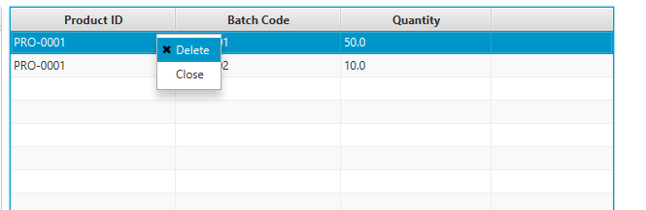

Figure - Table Right Click Menu - Send to Vehicle – Store

If you are in a vehicle already loaded, you may receive below confirmation dialogs accordingly.

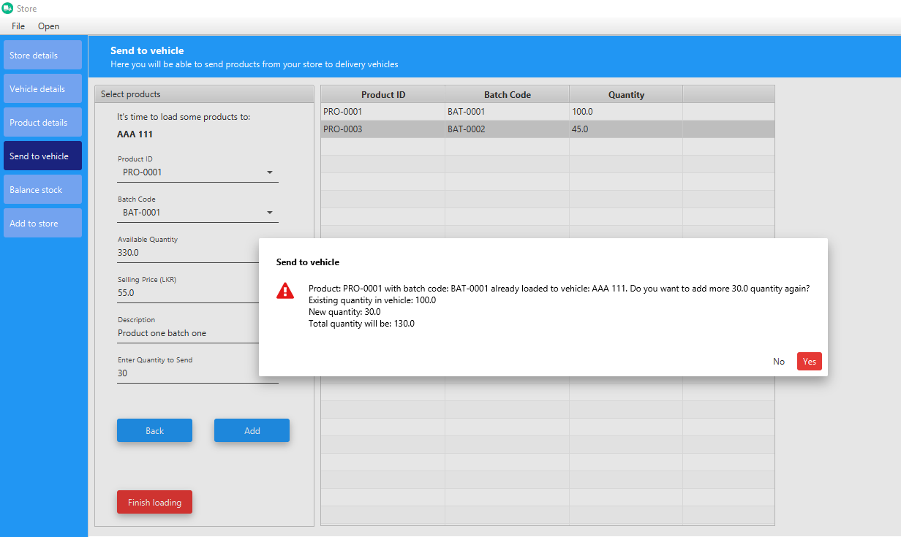

Figure - Add Quantity to Existing Product to Already loaded Vehicle - Send to Vehicle - Store

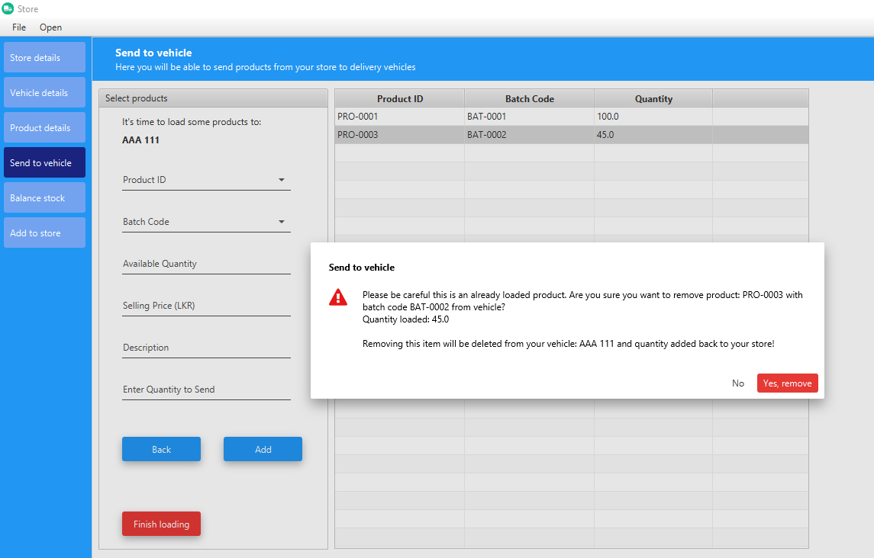

Figure - Deleting Product From Already Loaded Vehicle - Add to Vehicle –Store

## Balance Stock

After sending to vehicles you have to balance each vehicle according to your time frame. In here you can balance each vehicle separately.

First you have to select vehicle as shown in below image. You can use search option to search vehicle number or directly click on table row which contain relevant vehicle and then click “Next” to see what's loaded to the vehicle.

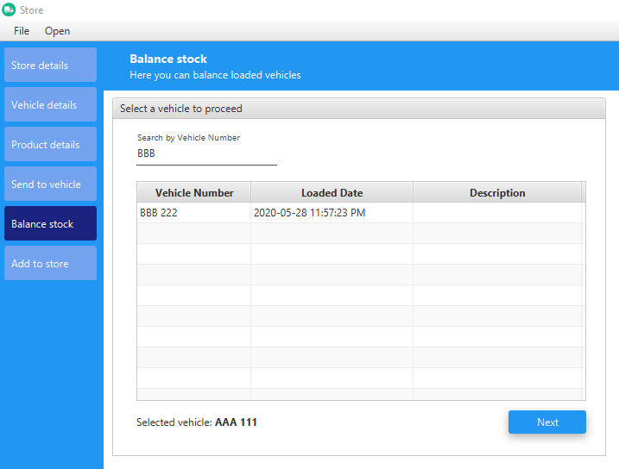

Figure - Select Loaded Vehicle - Balance Stock - Store

After this you will see interface like below image accordingly. Here you have ability to search by “Product ID or Batch Code”.

In order to add to “Sales” or “Returns”, what you have to do is select product from drop down and enter relevant quantity and click “Add to Sales” or “Add to Returns” accordingly. After completing this process, you can click “Finish” button to finish this process for selected vehicle.

With this process “Profit” and “Balance Reports” will be created for your reference. To access those refer reposts section in “Settings” window.

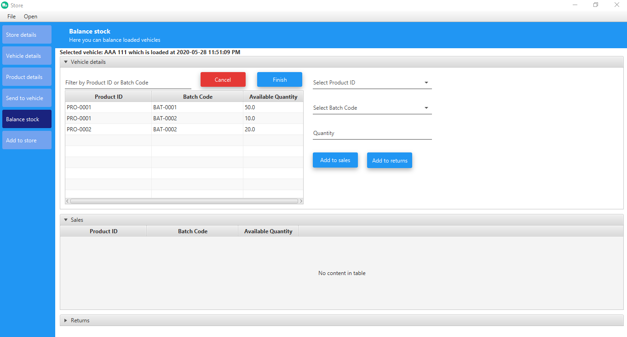

Figure - Loaded Vehicle Products - Balance Stock – Store

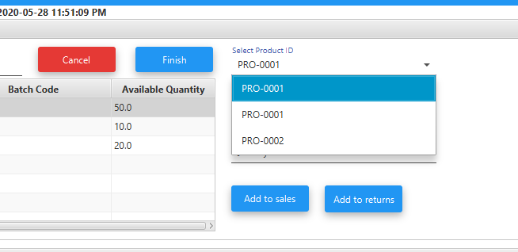

Figure - Product Selection - Balance Store - Store

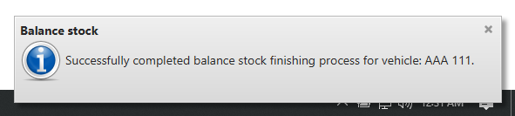

Figure - Balance Completed Notification - Balance Stock - Store

# **Settings**

In “Settings” window there are some important features including “Reports” module. You can use menu bar or side pane as of your preference to navigate through “Settings”.

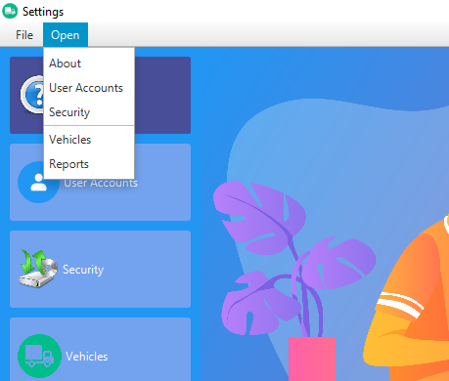

Figure - Menu Bar - Settings

## About

Here you have contact information’s in case if you want to get back to developer team of Store Monitor.

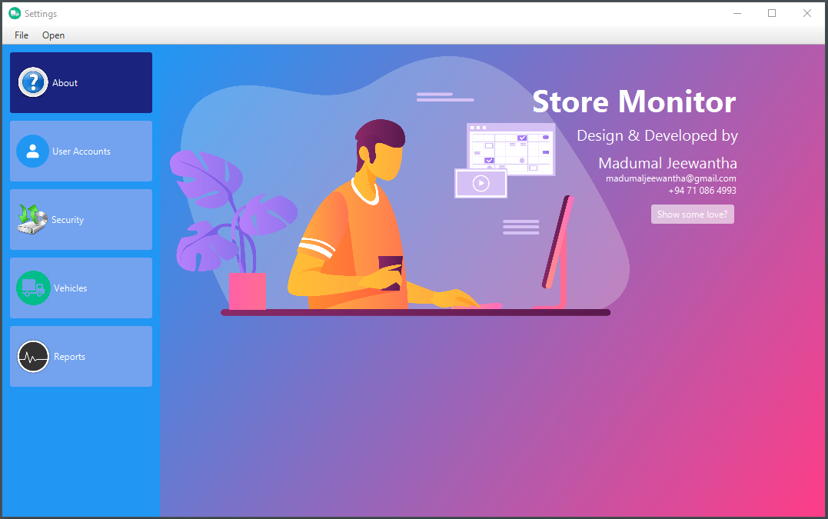

Figure - About – Settings

## User Accounts

Here you can change your user account password. After entering current password, it will appear interface to add new password.

Note: As of this release “Store Monitor” not supporting multiple users (It may include near future).

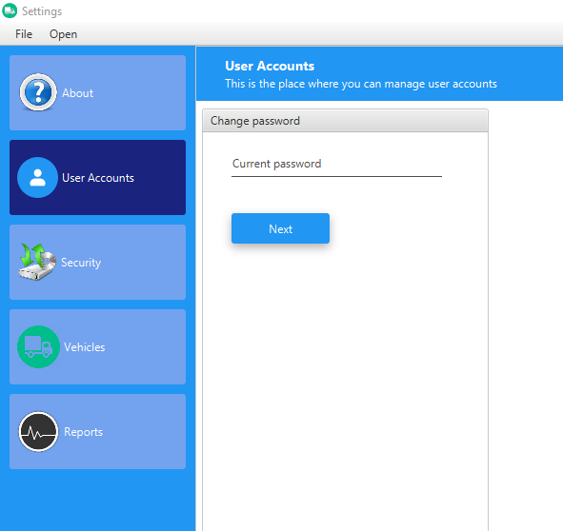

Figure - Change Password - User Accounts - Settings

## Security Center

This is a very important feature to prevent from **Data Loss** in order to manage smooth running. Highly recommend to make back up of “Store Monitor” related data using bellow “Backup” pane to external storage on every week basis (or a convenient time frame to you).

In case if you need to restore from your backed up data use “Restore” pane as shown in below image.

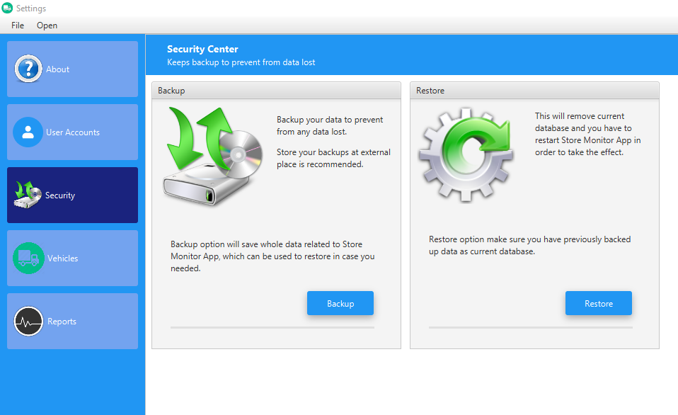

Figure - Security Center – Settings

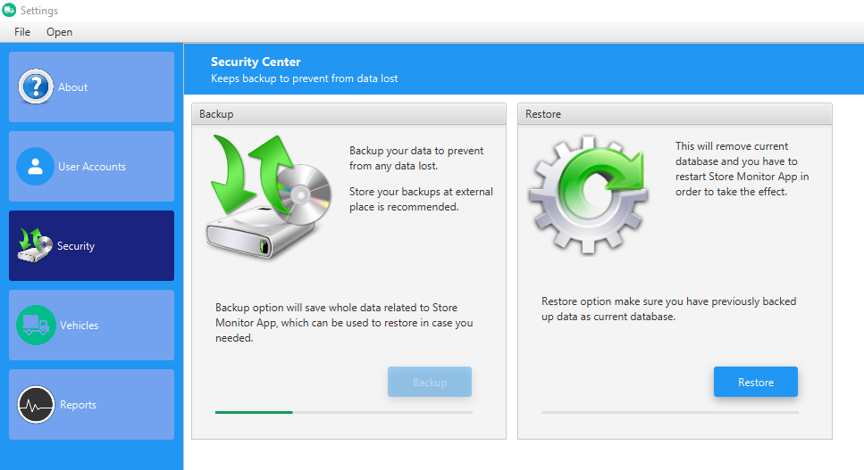

Figure - Backup In Progress - Security Center – Settings

## Vehicles

Here you can add vehicle details you are using for delivery purpose. There are features to add, update and delete vehicle details.

In order to use “Send to Vehicle”, you should have at least a one vehicle.

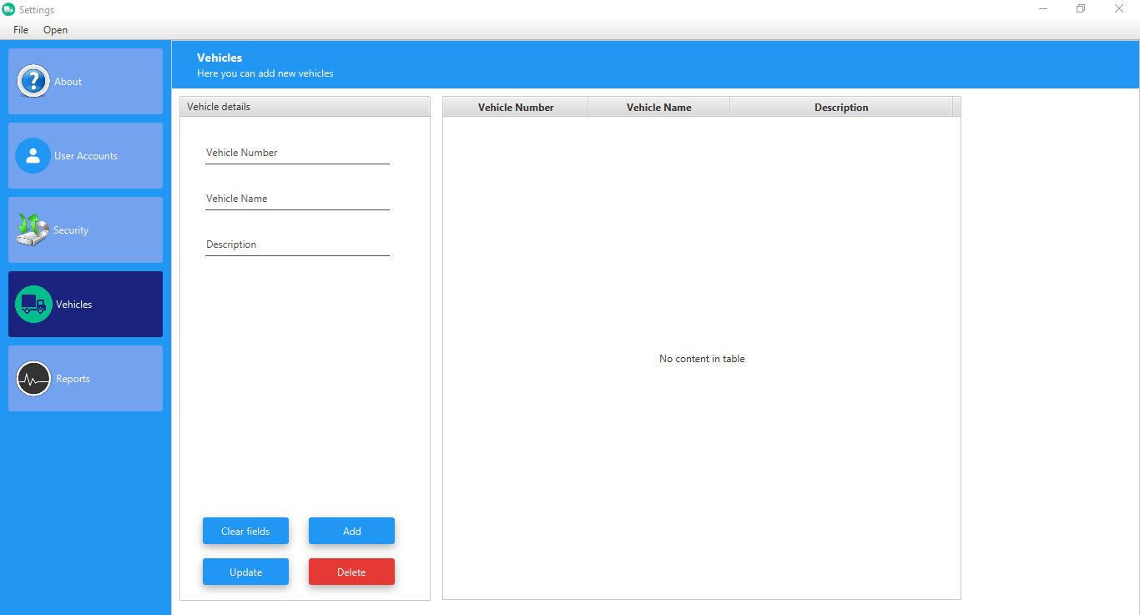

Figure - Vehicle Details – Settings

## Reports

This is a very important section of “Store Monitor” because this would be the ultimate goal of your business success path!

As showing in below image there are two charts. In the pie chart you can see the total profit amount for the current month by vehicles you having. In the line chart you can see total profit of the current year with regards to the months.

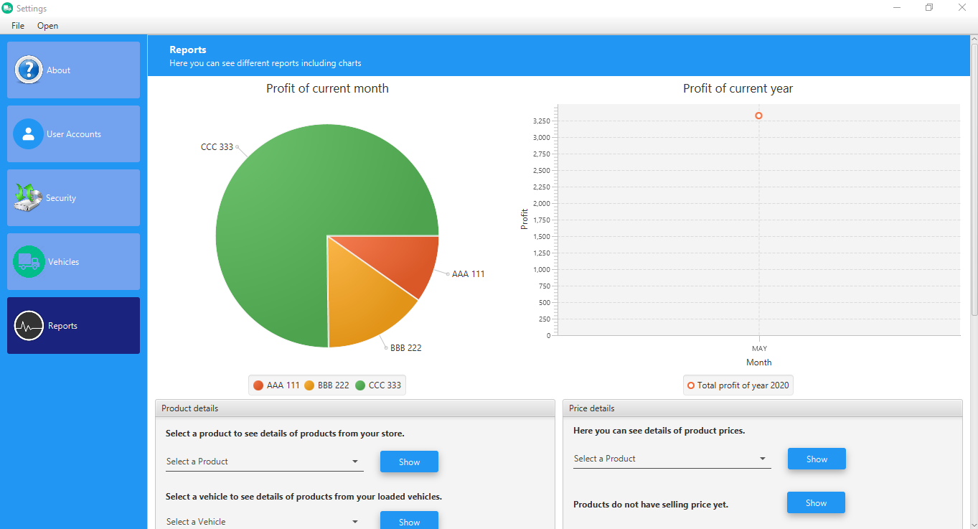

Figure - Reports – Settings

* Product details section

Show product details for selected product (You can select ‘All Products’ to see all the product details)

This will show products which are below re-order level

Here you can see expired products as of selected date

Show product details for selected vehicle – Loaded Vehicle (You can select ‘All Vehicles’ to see all the vehicles)

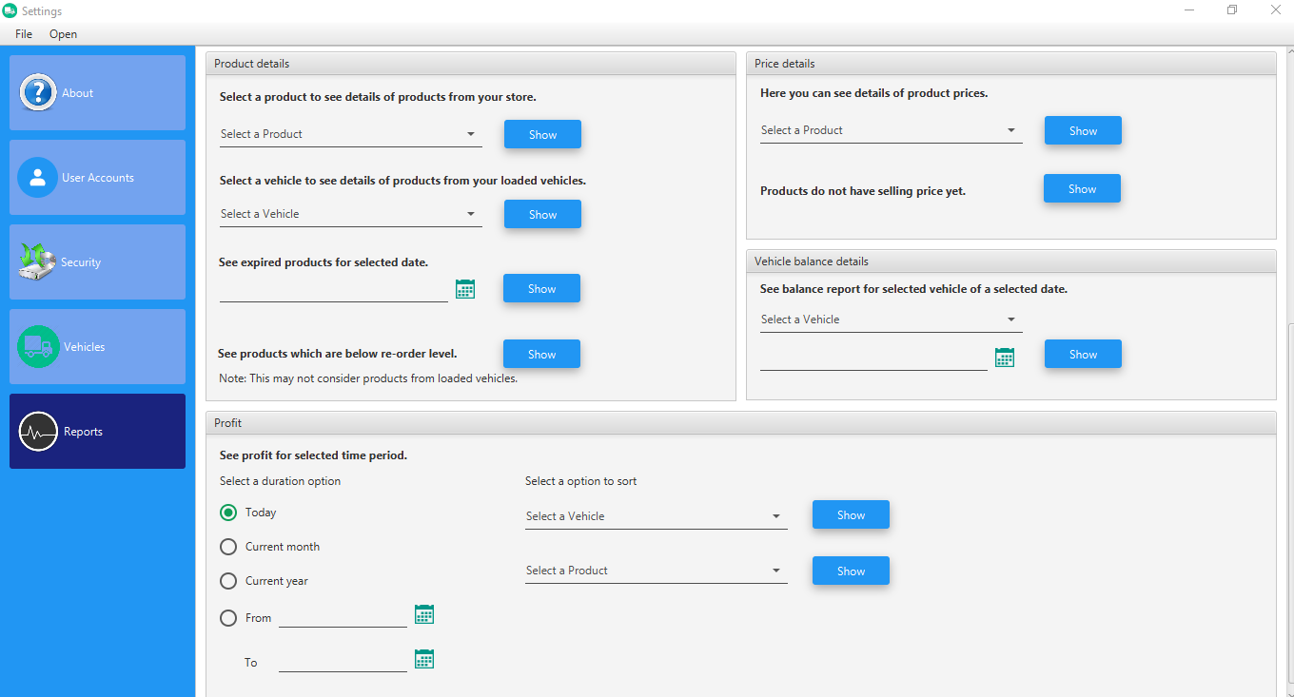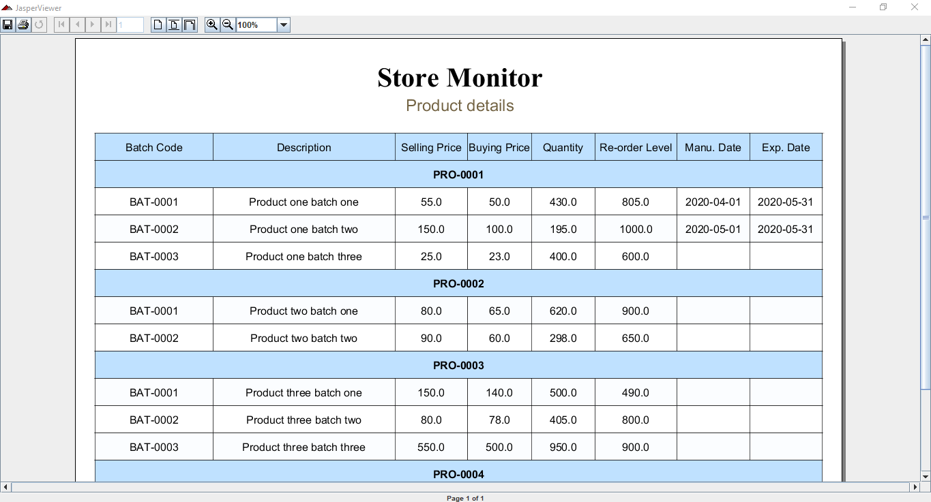

Figure 49 - Product Details - Report – Settings

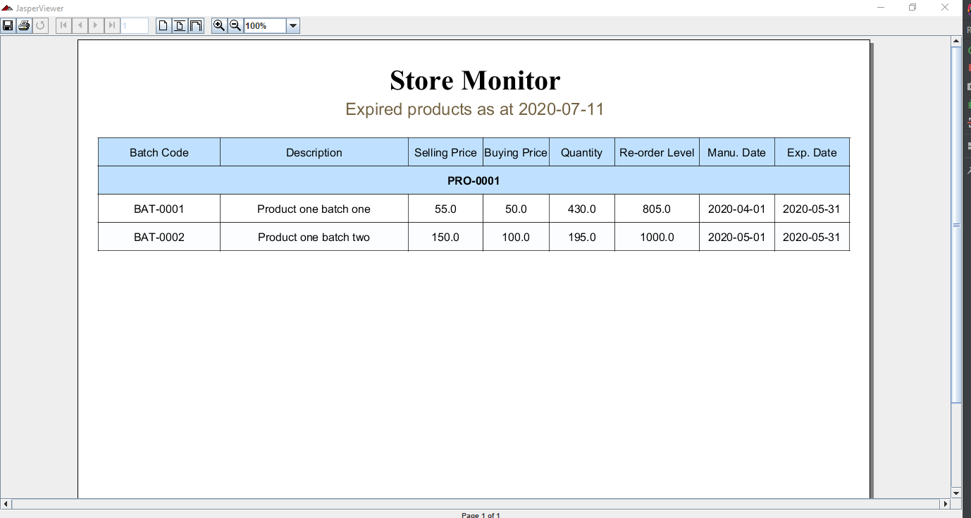

Figure 50 - Expired Products - Reports – Settings

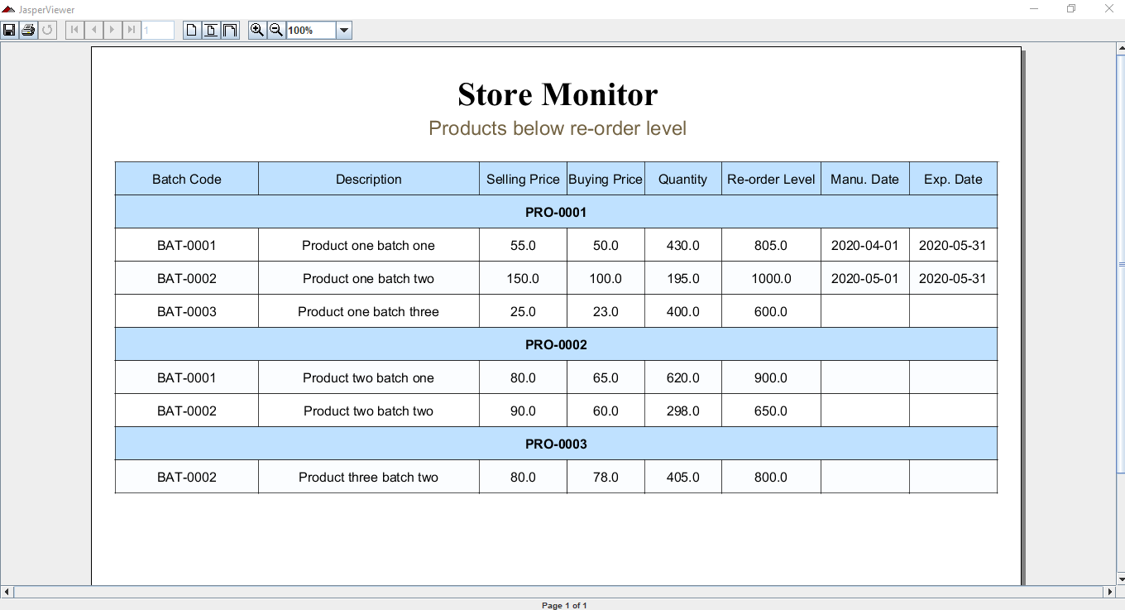

Figure 51Products Below Re-order Level - Reports – Settings

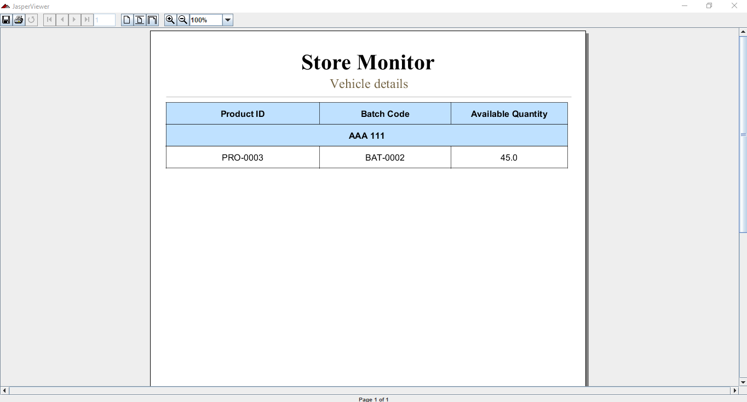

Figure 52 - Vehicle Store Details - Report – Settings

* Price details section

Show product prices for selected product (You can select “All Products) to see all product’s prices

To see products don’t have selling price yet

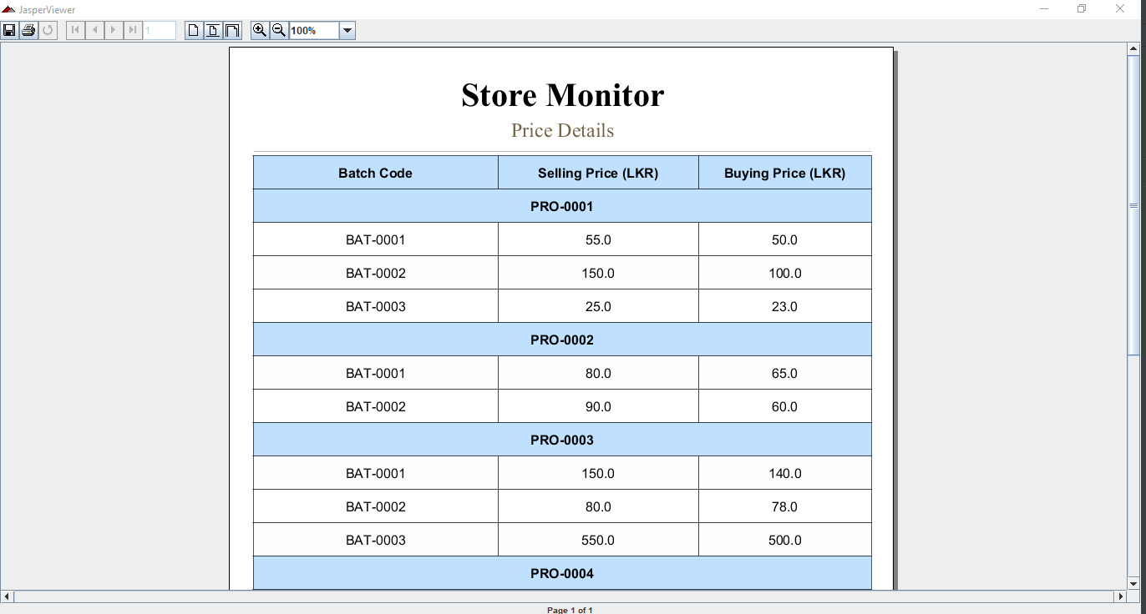

Figure 53 - Price Details – Settings

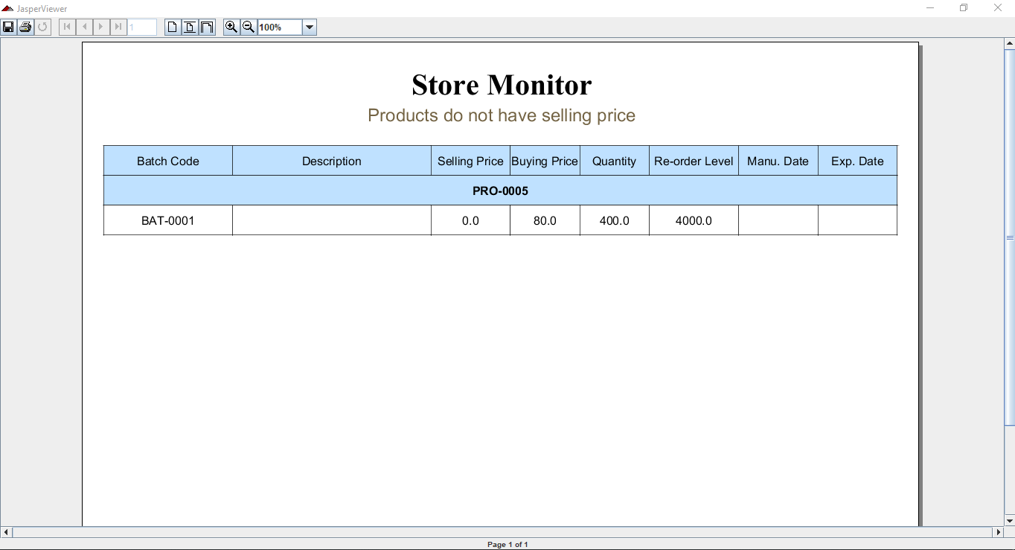

Figure 54 - Products Don't Have Selling Price - Reports – Settings

* Vehicle balance details section

In balance report there will be profit details, return products and remaining products.

Select a vehicle from drop down

Select a stock balanced date

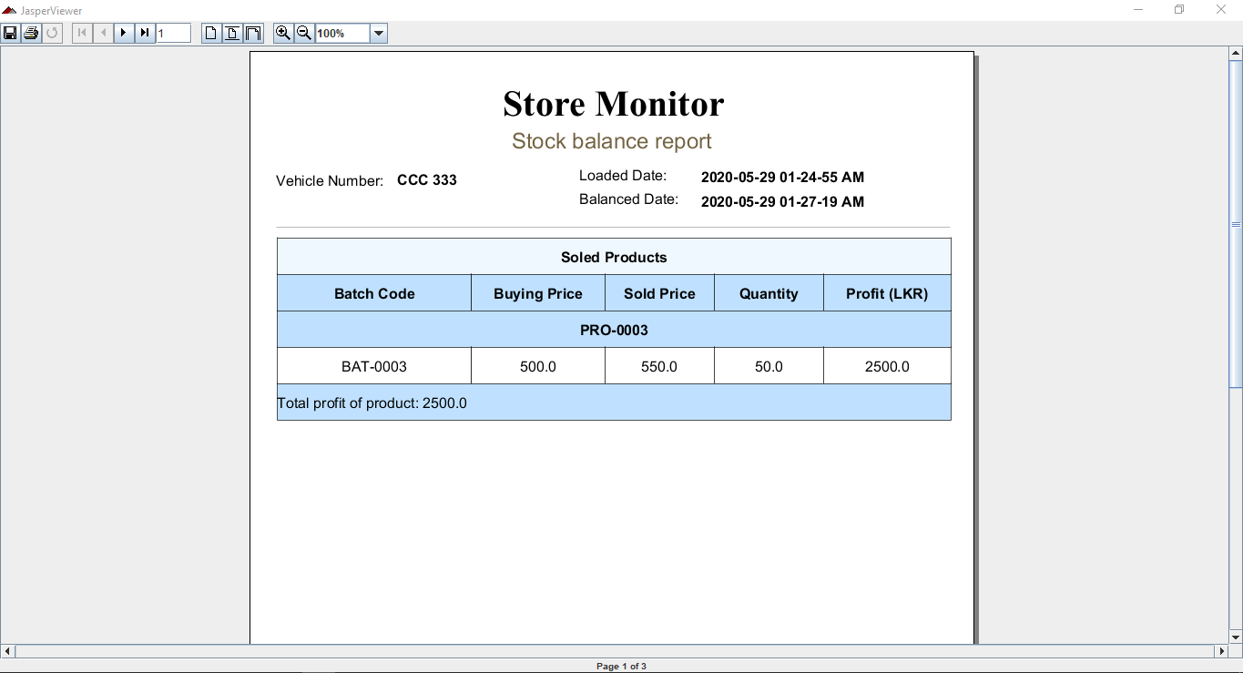

Figure 55 - Balance Report Page 1 - Reports – Settings

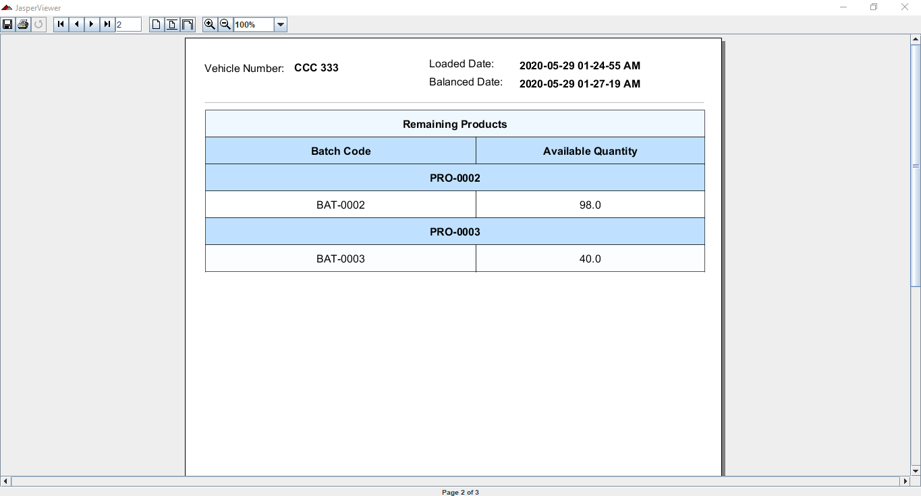

Figure 56 - Balance Report Page 2 - Reports – Settings

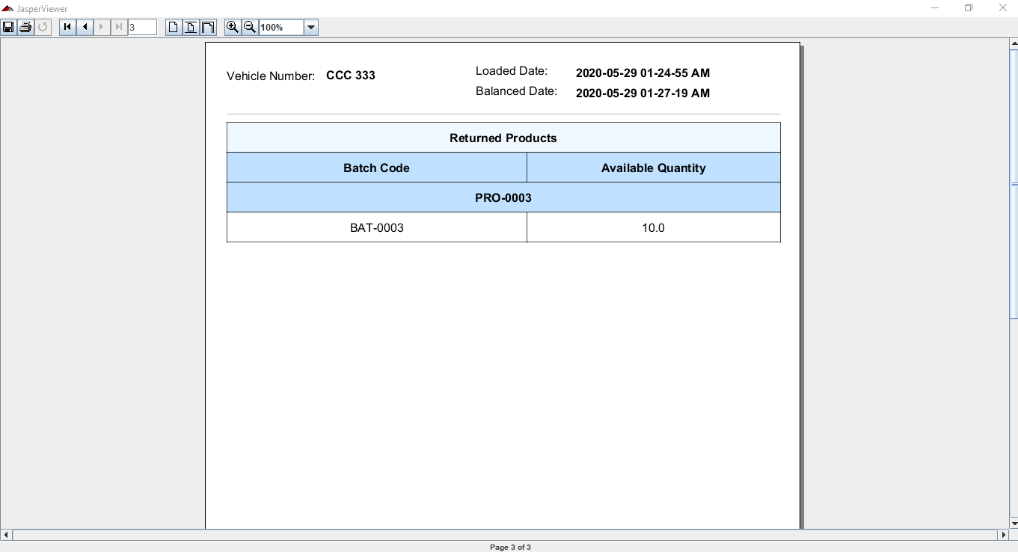

Figure 57 - Balance Report Page 3 - Reports – Settings

* Profit section

Show report by products

Show report by vehicles

Select time frame

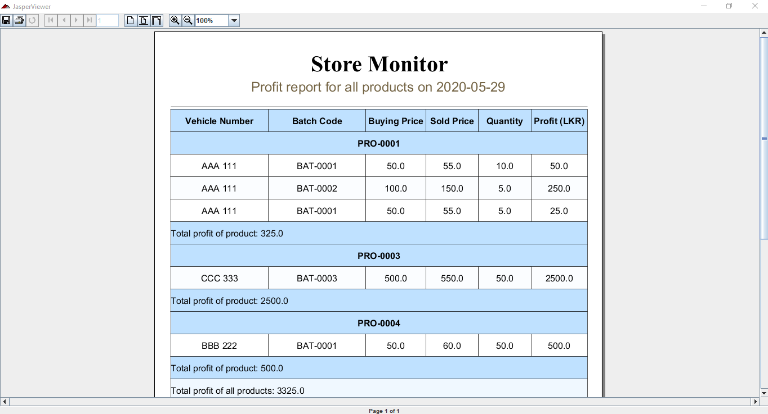

Figure 58 - Profit By Products - Reports – Settings

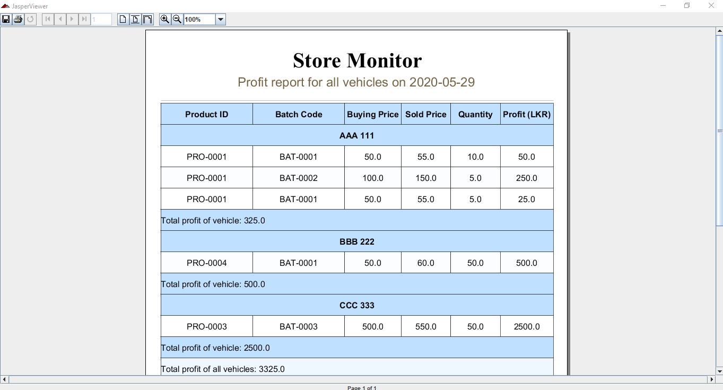

Figure 59 - Profit By Vehicles - Reports - Settings